## Assignment 1:

Draw your Home Network Topology and explain how you are accessing the RPS Lab environment.

**Home Network Topology :**

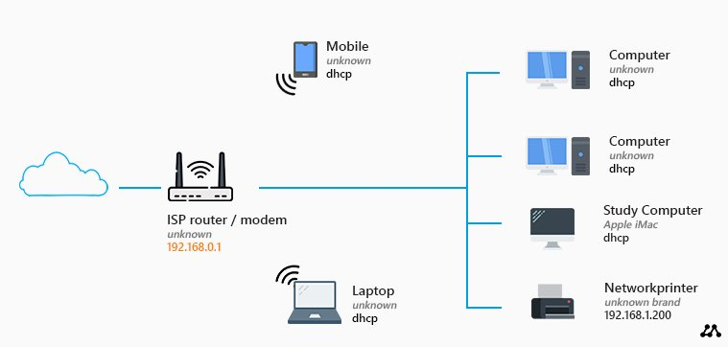I have a router with a built-in modem and an access point that I got from our ISP (Internet Service Provider). These kinds of routers typically allow us to connect up to four devices using a network (UTP) cable.

My home network starts with the internet connection from my ISP, which connects to a modem. The modem is connected to a router that provides both wired and wireless internet connections. My laptop, which I use to access the RPS Lab environment, is connected to the router via Wi-Fi.

To access the RPS Lab environment, I first connect my laptop to the internet using the Wi-Fi network. Then, I open my web browser and navigate to the RPS platform URL provided by Wipro. I log in using my credentials and can then access various resources, including recorded lectures, my progress report, and daily assignments. This setup allows me to efficiently manage and participate in my training program.

**Explanation of Accessing the RPS Lab Environment :**

1. **Internet Source**: The internet is provided by my Internet Service Provider (ISP), which connects to my home through a modem.
2. **Router/Modem**: The modem connects to a router that distributes the internet connection throughout my home.
3. **Wireless Access Point (WAP)**: The router also acts as a wireless access point, providing Wi-Fi connectivity to multiple devices.
4. **Devices Connected to the Network**:
   * **Laptop**: Connected via Wi-Fi.
   * **Smartphone**: Connected via Wi-Fi.

**Steps to Access the RPS Lab Environment:**

1. **Connecting to the Internet**: I connect my laptop or PC to the home network. If using a laptop, I connect via Wi-Fi; if using a PC, I connect via an Ethernet cable.
2. **Opening the Web Browser**: I open a web browser on my laptop or PC (e.g., Google Chrome, Mozilla Firefox).
3. **Navigating to the RPS Platform**: I enter the URL for the RPS platform provided by Wipro.
4. **Logging In**: I log in using my credentials (username and password) provided by Wipro.
5. **Accessing the RPS Lab**:

**Once logged in, I can access the following:**

* + - **Recorded Lectures**: I navigate to the section where recorded lectures are available and select the lecture I need to watch.
    - **Progress Report**: I go to the progress report section to review my training progress and performance.
    - **Meeting**: I check the daily meeting links to join easily in the meeting.

## Assignment 2:

Identify a real-world application for both parallel computing and networked system.

Explain how these technologies are used and why they are importance in the context.

Submission Guidelines:

1. Ensure that each answer is clear, concise, and reflects an understanding of the core concepts.

2. Diagrams can be hand-drawn and scanned or created using any digital drawing tool.

3. Provide references for any external sources used.

Submit your work in a single PDF document by end of Module

**Parallel Computing : -**

**Example** : Weather Forecasting

****Explanation**:** Weather forecasting is a complex process that requires the analysis of vast amounts of meteorological data from around the globe. This data includes temperature, humidity, wind speed, and atmospheric pressure, collected from satellites, weather stations, and other sources. The goal is to predict future weather conditions by running simulations using numerical weather prediction models.

****How Parallel Computing is Used** :**

* **Data Processing:** Parallel computing allows for the simultaneous processing of massive datasets. Different processors handle different portions of the data, significantly speeding up the analysis.
* **Simulations:** Weather models involve solving a large number of mathematical equations that describe atmospheric dynamics. These equations are divided into smaller parts and solved concurrently across multiple processors.
* **Real-Time Updates:** The use of parallel computing ensures that weather predictions can be updated in real-time as new data becomes available, providing more accurate and timely forecasts.

**Importance in Context:**

* **Accuracy:** Parallel computing enhances the accuracy of weather forecasts by enabling more detailed simulations and the ability to process more data in a shorter time.
* **Timeliness:** Faster processing times allow meteorologists to provide more timely warnings for severe weather events, helping to protect lives and property.
* **Resource Efficiency:** Efficient use of computational resources ensures that high-performance computing facilities can handle other critical tasks simultaneously.

**Networked System :** -

**Rainfall**

**Wind Speed**

**History Data’s**

**New Technology**

**and**

**Computing**

**Prediction**

**Temprature**

**Example** : Online Banking

****Explanation** :** Online banking is a system that allows customers to perform financial transactions via the internet. It involves a network of computers and servers that handle everything from account management to transaction processing.

**How Networked Systems are Used:**

* **Client-Server Architecture:** Customers use their devices (clients) to connect to the bank’s servers. The servers handle requests such as viewing account balances, transferring money, and paying bills.
* **Security Protocols:** Networked systems employ advanced security measures like encryption, firewalls, and secure login mechanisms to protect sensitive financial data.
* **Real-Time Processing:** Transactions are processed in real-time, enabling immediate updates to account balances and transaction histories.

**Importance in Context:**

* **Convenience:** Networked systems provide customers with 24/7 access to banking services from anywhere with an internet connection, enhancing user convenience.
* **Efficiency:** Automating financial transactions reduces the need for manual processing, saving time and resources for both the bank and its customers.
* **Security:** Robust networked systems ensure the security and integrity of financial data, protecting against fraud and cyber-attacks.

**Laptop**

**Smartphone**

**Tablet**

**Internet Connection**

**Bank’s Secure Servers**

**Authentication**

**Server**

**Transaction**

**Server**

**Database**

**Server**

**Security Measures**

**(Encryption, Firewalls)**

**Online Banking Services**

### References

1. "Parallel Computing for Weather Prediction," National Center for Atmospheric Research (NCAR).
2. "The Importance of Networked Systems in Online Banking," Journal of Financial Services.